DEPARTMENT OF INFORMATION TECHNOLOGY
PUDUCHERRY TECHNOLOGICAL UNIVERSITY
VIII SEMESTER

IT233 – PROJECT WORK

FIRST REVIEW PROJECT REPORT 2025-26

AGRITWIN-GH: AGRICULTURAL DIGITAL TWIN FOR SMART GREENHOUSE HORTICULTURE OF TOMATO CULTIVATION

UNDER THE SUPERVISION OF
DR. V. GOVINDASAMY
PROFESSOR
DEPARTMENT OF INFORMATION TECHNOLOGY
PUDUCHERRY TECHNOLOGICAL UNIVERSITY

SUBMITTED BY
ARJUN CHRISTOPHER - 2201112007
BHUVANALAKSHMI J P - 2201112009
VANTAPATI RAJA RAJESWARI - 2201112052

Signature of the Guide

TABLE OF CONTENTS
Title | Page No.
1. Abstract ………………………...……………………………………. | 1
2. Introduction to Techniques and Algorithms Used …………………… | 1
2.1 Convolutional Neural Networks …………….…………………… | 2
2.2 Transfer Learning ……………….……………………………...... | 2
2.3 EfficientNet Architecture ……………………..………………...... | 2
2.4 Image Data Augmentation …………………………..…………… | 3
3. Literature Survey ……………………………….…………………… | 3
3.1 Inference from Literature Survey ………………………………… | 4
4. High-Level Architecture ……………………..……………………… | 5
4.1 System Inputs and Expected Output ……………………………… | 5
5. Project Modules ……………………………………………...……… | 6
5.1 Data Processing and AI-Based Crop Intelligence ……...………… | 7
5.2 Predictive Analytics and Crop Health Forecasting ………..……... | 8
5.3 Digital Twin Simulation and Intelligent Greenhouse Control ….... | 10
6. Module 1 — Data Processing and AI-Based Crop Intelligence……..... | 11
6.1 Overview of the Module ……………………………………........ | 11
6.2 Unified Data Processing Pipeline ………………………………... | 12
6.3 AI-Based Crop Intelligence Workflow ………….…………….… | 13
6.4 Component-Level Design of the Module ……………..…………. | 13
6.5 Module Demonstration ………………………….……………..... | 15
6.6 Implementation Results and Performance Analysis ……………... | 22
7. Conclusion ……………………….………………………….............. | 26
8. Datasets Used ………………………………...……………………… | 26
9. References ………………………………..…………………………. | 27

LIST OF FIGURES
Figure No. | Figure Title | Page No.
4.1 | High-Level Architecture Diagram of AgriTwin-GH …………...….… | 5
5.2 | Task-Level Architecture of Data Processing and AI-Based Crop Intelligence Module …………….………………………………………… | 7
5.3 | Task-Level Architecture of Predictive Analytics and Crop Health Forecasting Module …………….………………………...……………… | 8
5.4 | Task-Level Architecture of Digital Twin Simulation and Intelligent Greenhouse Control Module …………….……..………………………… | 10
6.1 | Data Processing Pipeline Architecture …………….………..….………… | 13
6.2 | Growth Stage Classification and Disease Detection Workflow ………….. | 14
6.3 | Architectural Component Design of Module 1 …………………………… | 15
6.4 | Extract of the Dindigul Weather Dataset ...……….………………………. | 16
6.5 | Tomato Leaf Disease Classification Dataset Samples ……….…………… | 19
6.6 | Phase-1 Warm-Up Training Results for Disease Classification Model ….. | 20
6.7 | Phase-2 Fine-Tuning Results for Disease Classification Model ………….. | 20
6.8 | Tomato Crop Growth Stages Dataset Samples ………………..…………. | 21
6.9 | Phase-1 Warm-Up Training Results for Growth Stage Classification Model ……………………………………………………..……………… | 22
6.10 | Phase-2 Fine-Tuning Results for Growth Stage Classification Model ….. | 22
6.11 | Processed Greenhouse Environmental Dataset Sample ……………..…… | 23
6.12 | Confusion Matrix of Tomato Disease Detection Model ………….……… | 23
6.13 | Training Accuracy of the Disease Detection Model ……….……..……… | 24
6.14 | Training Loss of the Disease Detection Model ………………….…..…… | 24
6.15 | Confusion Matrix of Tomato Growth Stage Classification Model …..…... | 25
6.16 | Training Accuracy of the Growth Stage Classification Model …………… | 25
6.17 | Training Loss of the Growth Stage Classification Model …………..…….. | 26

ABBREVIATIONS

Abbreviation |  | Full Form
AI | Artificial Intelligence
CNN | Convolutional Neural Network
RNN | Recurrent Neural Network
LSTM | Long Short-Term Memory
TTA | Test Time Augmentation
DT | Digital Twin
MPC | Model Predictive Control
VPD | Vapor Pressure Deficit
RH | Relative Humidity
CO₂ | Carbon Dioxide
EC | Electrical Conductivity
IoT | Internet of Things
CV | Computer Vision
ML | Machine Learning
DL | Deep Learning
GUI | Graphical User Interface
API | Application Programming Interface
RGB | Red, Green, Blue

1. ABSTRACT
Greenhouse cultivation of high-value crops such as tomatoes faces persistent challenges related to environmental variability, delayed disease detection, inefficient resource usage, and reliance on reactive manual decision-making. Conventional greenhouse management systems often lack predictive intelligence and fail to provide early warnings for disease risks, resulting in yield loss, quality degradation, and excessive consumption of water, energy, and fertilizers.
To address these limitations, this project presents AgriTwin-GH, a software-based AI-powered digital twin framework for smart greenhouse management. The proposed framework leverages data-driven analysis of greenhouse environmental conditions and plant health information to enable early disease risk awareness, future condition assessment, and proactive decision support. Instead of relying on physical sensor infrastructure, the system operates using open-source greenhouse datasets and plant image data, allowing flexible experimentation and cost-effective deployment.
AgriTwin-GH provides disease-aware predictions, greenhouse condition forecasts, and safety-validated control recommendations, which are translated into simple non-verbal operational alerts for practical usability in labor-intensive greenhouse environments. By shifting greenhouse operations from reactive responses to predictive and preventive management, the framework improves crop productivity and quality while significantly reducing unnecessary water, energy, and fertilizer usage.
The results offer a scalable, resource-efficient, and decision-oriented digital twin solution for precision greenhouse horticulture, making it particularly suitable for resource-constrained and small-to-medium-scale farming systems.
Keywords
Digital Twin, Smart Greenhouse, Time-Series Dataset, Plant Image Dataset, CNN, RNN, Model Predictive Control, Disease Prediction, Environmental Forecasting, Disease Risk Prediction, Precision Agriculture

2. INTRODUCTION TO TECHNIQUES AND ALGORITHMS USED
Modern smart agriculture systems increasingly rely on advanced computational techniques to analyze environmental conditions and plant health. The integration of artificial intelligence, machine learning, and computer vision technologies enables automated monitoring and decision-making in greenhouse environments. These techniques help identify plant diseases, track crop development, and analyze environmental parameters that influence plant growth.
This section provides an overview of the fundamental algorithms and techniques commonly used in intelligent agricultural monitoring systems. The concepts discussed form the theoretical foundation for the development of data-driven greenhouse monitoring and crop analysis systems.

2.1 CONVOLUTIONAL NEURAL NETWORKS
Convolutional Neural Networks (CNNs) are a type of deep learning architecture specifically designed for image processing and computer vision tasks. CNNs are capable of automatically learning spatial features from images, making them highly suitable for analyzing visual data such as plant leaves, fruits, and crop images.
A CNN typically consists of convolution layers, pooling layers, and fully connected layers. The convolution layers extract important visual patterns such as edges, textures, and shapes, while pooling layers reduce the dimensionality of feature maps to improve computational efficiency. The final layers of the network perform classification based on the extracted features.
CNNs have become the standard approach for image-based agricultural applications because they can accurately identify visual patterns associated with plant diseases, nutrient deficiencies, and growth stages.
2.2 TRANSFER LEARNING
Transfer learning is a technique in machine learning where a model trained on a large dataset is reused and adapted for a different but related task. Instead of training a deep learning model from scratch, a pre-trained model is used as a starting point and then fine-tuned using a smaller, task-specific dataset.
This approach significantly reduces the amount of training data and computational resources required. Pre-trained models typically learn general visual features during initial training, which can then be applied to new problems with minimal modification.
Transfer learning has become widely used in computer vision applications because it enables high model performance even when limited labeled data is available.
2.3 EFFICIENTNET ARCHITECTURE
EfficientNet is a modern deep learning architecture designed to improve the performance and efficiency of convolutional neural networks. Traditional CNN architectures often increase network depth or width to improve accuracy. EfficientNet introduces a compound scaling method that balances network depth, width, and input resolution to achieve better performance with fewer parameters.
This balanced scaling approach allows EfficientNet models to achieve high accuracy while maintaining computational efficiency. As a result, EfficientNet architectures are widely used in image classification tasks where both performance and computational efficiency are important.
EfficientNet models have demonstrated strong performance in various computer vision applications, including plant disease detection, object recognition, and medical image analysis.

2.4 IMAGE DATA AUGMENTATION
Image data augmentation is a technique used to artificially increase the size and diversity of image datasets used for training machine learning models. It involves applying various transformations to existing images to create new training samples.
Common augmentation techniques include rotation, flipping, scaling, cropping, and adjustments to brightness or contrast. These transformations simulate real-world variations that may occur during image acquisition, such as changes in camera angle, lighting conditions, or object orientation.
By increasing dataset diversity, data augmentation helps improve the robustness of machine learning models and reduces the risk of overfitting.
3. LITERATURE SURVEY
The study by Elbasi et al. emphasize the importance of effective data preprocessing before applying machine learning models to agricultural datasets. The preprocessing stage involves several steps to transform raw agricultural data into a structured format suitable for model training [1]. Initially, noisy and mislabeled records are identified and removed to improve data reliability. The dataset is then balanced to ensure that each class label contains an equal number of samples, reducing bias during model training. To further enhance learning performance, the data records are randomly shuffled to provide a uniform distribution across the dataset. Feature selection is performed using correlation analysis to identify the most relevant attributes influencing agricultural outcomes. Additionally, new features are generated from existing attributes using statistical measures such as minimum, maximum, and range values to enrich the feature space. The dataset is then restructured into a consistent format and dimensionality reduction techniques are applied to eliminate redundant or less informative features.
A study by Oad et al. proposed an advanced plant disease detection framework based on ensemble deep learning combined with explainable artificial intelligence (XAI). The primary objective of the research was to improve the accuracy and interpretability of automated plant disease diagnosis using leaf images [10]. The methodology integrates multiple deep convolutional neural network (CNN) architectures, including VGG16, VGG19, InceptionV3, and ResNet101V2, within an ensemble learning framework. Each model independently performs feature extraction and classification of plant leaf images. The outputs of these individual models are then aggregated using ensemble voting techniques such as hard voting and soft voting, where the final prediction is determined either by majority class votes or by combining prediction confidence scores. This ensemble strategy improves prediction robustness and minimizes the limitations of relying on a single deep learning model. The dataset used for training and evaluation was the PlantVillage dataset, which contains more than 54,000 images of healthy and diseased plant leaves across 38 disease classes and multiple crop species. Prior to model training, several image preprocessing and augmentation techniques were applied, including rescaling pixel values, rotation, zooming, shearing, and horizontal flipping, in order to improve model generalization and reduce overfitting. Each CNN architecture was trained using softmax activation for multi-class classification and categorical cross-entropy as the loss function, optimized using the Adam optimizer. Experimental results showed that the individual models achieved high classification accuracy, with VGG16 reaching approximately 91.9% accuracy, VGG19 around 88.2%, InceptionV3 about 88%, and ResNet101V2 achieving approximately 93.6% accuracy.
Huo et al. proposed a deep learning-based framework for automatic identification of tomato growth stages in protected agriculture environments. The study addresses limitations of traditional monitoring methods that rely on manual observation, which are time-consuming, subjective, and inefficient for large-scale greenhouse cultivation [4]. To overcome these issues, the authors introduced a hybrid approach combining Generative Adversarial Networks (GANs) and Vision Transformer (ViT) models for accurate growth stage recognition. In the proposed methodology, the StyleGAN3 architecture is used to generate high-quality synthetic images of tomato plants at different growth stages. These generated images are combined with real images to augment the dataset, thereby increasing the diversity of training data and reducing the impact of limited sample availability in agricultural datasets. After dataset augmentation, the classification of tomato growth stages is performed using the Vision Transformer (ViT) model, a deep learning architecture that utilizes a self-attention mechanism to capture global relationships within image features. Unlike traditional Convolutional Neural Networks (CNNs), the ViT model processes images as sequences of patches and analyzes long-range dependencies between them, enabling improved recognition of complex visual patterns associated with plant growth stages. The model was trained on a dataset consisting of 2723 images of tomato plants across multiple growth phases, including sapling, flowering, fruiting, and maturity stages. The combined dataset containing both real and GAN-generated images significantly enhanced model performance compared to training with only original images. Experimental evaluation demonstrated that the proposed approach achieved highly accurate recognition results.
3.1 INFERENCE FROM LITERATURE SURVEY
The literature review indicates that effective data preprocessing plays a critical role in improving the performance of machine learning models in agricultural applications. Previous studies have focused on preprocessing techniques such as noise removal, dataset balancing, feature selection, and statistical feature generation to transform raw agricultural data into structured datasets suitable for machine learning models. However, these approaches mainly focus on preparing datasets for model training rather than developing a comprehensive environmental data processing pipeline. In contrast, the proposed AgriTwin-GH framework implements a unified greenhouse data processing architecture that integrates multi-source environmental data ingestion, temporal synchronization, and environmental feature engineering to generate standardized datasets suitable for intelligent greenhouse analysis.
Existing research on plant disease detection has demonstrated that deep learning architectures, particularly convolutional neural networks and ensemble learning models, can achieve high accuracy in leaf disease classification tasks. Methods combining multiple CNN architectures and ensemble voting strategies have improved prediction robustness by leveraging complementary feature extraction capabilities of different models. Nevertheless, such approaches often involve high computational complexity and limited interpretability when deployed in real-world greenhouse monitoring systems. In the proposed system, disease detection is implemented using an EfficientNet-based deep learning model that provides high classification accuracy while maintaining computational efficiency suitable for real-time greenhouse monitoring environments.
For tomato growth stage recognition, several studies have explored complex architectures such as transformer-based models and generative adversarial networks for improving classification performance. In contrast, the proposed work adopts an EfficientNet-based deep convolutional neural network architecture optimized for agricultural image analysis, enabling highly efficient feature extraction with reduced computational overhead. The EfficientNet model leverages compound scaling of network depth, width, and resolution to capture detailed morphological characteristics of tomato plants across different growth phases, resulting in improved classification accuracy and robust growth stage prediction suitable for intelligent greenhouse monitoring systems.
4. HIGH-LEVEL ARCHITECTURE
Fig. 4.1 illustrates the high-level architecture of the proposed AgriTwin-GH framework, depicting the flow of data from input acquisition to intelligent decision outputs. The architecture is structured into three primary layers: input data sources, core processing modules, and system outputs.
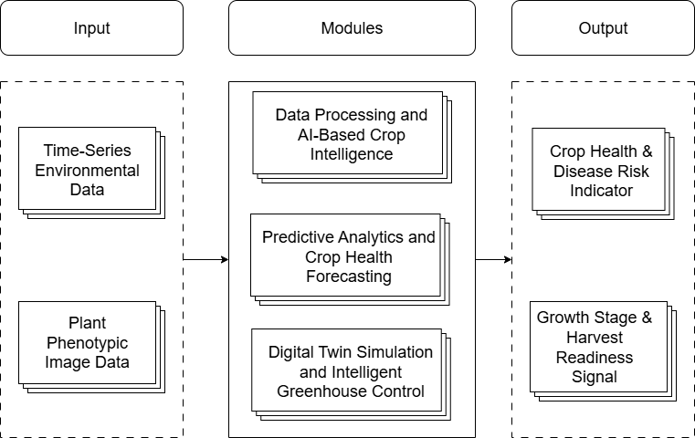
Fig. 4.1 High-Level Architecture Diagram of AgriTwin-GH
4.1 SYSTEM INPUTS AND EXPECTED OUTPUT
A. System Inputs
The proposed system operates using data-driven inputs obtained from open-source datasets that emulate real greenhouse environments. These datasets act as virtual sensors, enabling experimentation and analysis without relying on physical sensor infrastructure, while still reflecting realistic greenhouse behavior.
Open-Source Environmental Data
The environmental dataset used in this study is derived from real-world weather observations collected for the Dindigul district of Tamil Nadu, India. The weather data for the years 2024 and 2025 were obtained using the Visual Crossing Weather API, which provides historical meteorological records including parameters such as temperature, humidity, solar radiation, and wind speed. These datasets represent actual environmental conditions of the region and serve as the primary source for environmental analysis within the system.
Using this real-world weather data as the foundation, an indoor greenhouse environmental dataset was generated to simulate greenhouse conditions. The derived dataset represents indoor greenhouse parameters influenced by the outdoor climate and includes variables such as indoor temperature, humidity, air velocity, solar radiation, carbon dioxide concentration, vapor pressure deficit, and leaf wetness indicators. Both the original API-based weather dataset and the generated indoor greenhouse dataset are utilized as environmental inputs for further analysis and system modeling.
Open-Source Plant Image Data
Plant image datasets related to tomato cultivation are used to assess crop health and growth stages. These images include healthy and diseased leaves and different growth phases. Image data enable visual identification of disease symptoms and crop development, strengthening plant health analysis.
B. System Outputs and Expected Outcomes
The system produces outputs that support predictive decision-making and intelligent greenhouse management.
Crop Health and Disease Risk Indicator
This output provides an overall assessment of plant health and disease risk by combining environmental data and image-based analysis. It supports early detection of potential disease conditions and preventive greenhouse management.
Growth Stage and Harvest Readiness Signal
The system identifies the current growth stage of crops and indicates harvest readiness, especially for tomato cultivation, where correct harvest timing is critical for quality and yield.
Expected Outcomes
The expected outcomes include successful demonstration of a sensor-independent digital twin framework, early disease risk identification, accurate growth stage prediction, improved decision support, and reduced dependence on physical greenhouse infrastructure.
5. PROJECT MODULES
The proposed AgriTwin-GH system is organized into multiple functional modules that collectively enable intelligent greenhouse monitoring, predictive crop analysis, and automated decision support. Each module performs a specific set of operations within the system workflow, beginning from data processing and crop analysis to predictive modeling and digital twin–based greenhouse control. The modular architecture allows the system to process environmental and image data efficiently while supporting scalable integration of analytical and simulation components.
5.1 DATA PROCESSING AND AI-BASED CROP INTELLIGENCE
This module focuses on preparing agricultural datasets and performing crop condition analysis using machine learning and computer vision techniques. It transforms raw environmental and plant image data into meaningful insights that support greenhouse crop monitoring. By integrating data preprocessing procedures with deep learning models, the module enables accurate identification of plant growth stages and early detection of plant diseases.
Fig. 5.2 illustrates the task-level decomposition of the Data Processing and AI-Based Crop Intelligence Module in the AgriTwin-GH system. It shows how environmental and plant image data are processed to perform data preparation, crop growth stage classification, and plant disease detection.
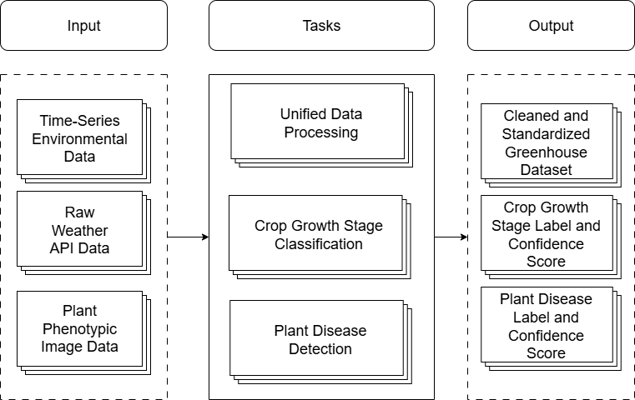
Fig. 5.2 Task-Level Architecture of Data Processing and AI-Based Crop Intelligence Module
A. Unified Data Processing
The unified data processing task is responsible for transforming heterogeneous greenhouse datasets into a standardized structure suitable for analytical and machine learning applications. Agricultural data may originate from different external sources and may contain inconsistencies, noise, or missing values. This task performs multi-source data ingestion and applies validation and cleansing procedures to ensure data quality. Missing values are handled appropriately, while noise filtering and outlier removal techniques are used to improve dataset reliability. Temporal synchronization is also carried out to align environmental variables collected at different time intervals. In addition, feature engineering methods are applied to generate derived environmental indicators that support further crop analysis and predictive modeling processes.
B. Crop Growth Stage Classification
The crop growth stage classification task focuses on identifying the current development stage of tomato plants using image-based deep learning models. Recognizing plant growth stages is important for monitoring crop development and determining appropriate cultivation actions during different phases of the plant lifecycle. In this task, plant images are first preprocessed to ensure consistent input quality for the deep learning model. A convolutional neural network is then used to analyze visual patterns in the plant images and classify the corresponding growth stage. The model generates probability scores representing the likelihood of different growth stages, allowing accurate identification of plant development phases. Model fine-tuning is performed using greenhouse crop image datasets to improve classification accuracy under varying environmental conditions.
C. Plant Disease Detection
The plant disease detection task aims to identify diseases affecting greenhouse crops using computer vision techniques. Early detection of plant diseases plays a critical role in preventing crop damage and maintaining healthy plant growth. In this task, plant images are analyzed using trained deep learning models capable of recognizing disease patterns present on leaves and plant surfaces. The system performs image-based disease classification and estimates the probability of disease occurrence. By identifying major greenhouse crop diseases at an early stage, the system supports timely intervention and effective disease management. The task also enables real-time disease alert generation to assist greenhouse operators in monitoring crop health conditions.
5.2 PREDICTIVE ANALYTICS AND CROP HEALTH FORECASTING
This module performs predictive analysis to anticipate crop health risks, forecast plant growth progression, and analyze environmental trends affecting greenhouse cultivation. By utilizing temporal environmental data and predictive modeling techniques, the module enables the system to estimate future crop conditions and environmental states. These predictions assist greenhouse operators in making proactive decisions to maintain optimal plant growth conditions and reduce the risk of crop diseases.
Fig. 5.3 illustrates the task-level decomposition of the Predictive Analytics and Crop Health Forecasting Module. The module analyzes greenhouse environmental data and crop analysis outputs to predict disease risk, forecast growth progression, and estimate future environmental conditions.
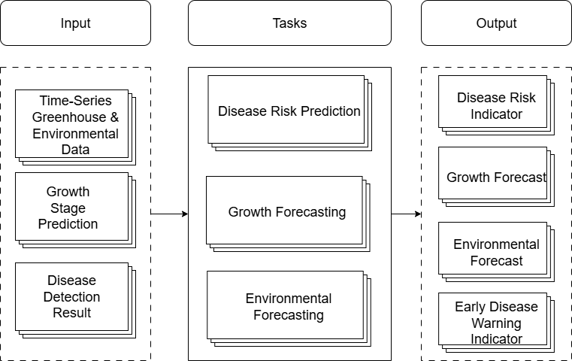
Fig. 5.3 Task-Level Architecture of Predictive Analytics and Crop Health Forecasting Module
A. Disease Risk Prediction
The disease risk prediction task focuses on estimating the probability of disease occurrence based on greenhouse environmental conditions. Plant diseases are often influenced by environmental factors such as humidity, temperature, and moisture duration. This task analyzes environmental patterns and calculates a disease risk index that represents the likelihood of disease development under current greenhouse conditions. The system evaluates humidity duration, temperature–humidity interactions, and other environmental factors to determine disease risk levels. When the calculated risk exceeds predefined thresholds, the system generates early warning alerts to support preventive disease management strategies.
B. Growth Progression Forecasting
The growth progression forecasting task aims to predict future plant growth stages using temporal environmental data. Plant growth is strongly influenced by environmental conditions over time, making time-series analysis important for understanding crop development patterns. This task utilizes sequence-based modeling techniques to analyze environmental trends and forecast plant growth progression. The model estimates the likely transition of plant growth stages within a defined time horizon and generates short-term predictions of plant development. By forecasting plant growth progression, the system supports improved crop monitoring and helps greenhouse operators anticipate upcoming cultivation requirements.
C. Environmental Condition Forecasting
The environmental condition forecasting task focuses on predicting future greenhouse environmental parameters that influence crop growth. Environmental variables such as temperature, humidity, and carbon dioxide concentration significantly affect plant development and disease susceptibility. This task analyzes historical environmental patterns to forecast upcoming environmental conditions within the greenhouse. The system also performs environmental trend analysis to identify potential anomalies or irregular sensor readings. These predictions provide valuable insights for maintaining stable greenhouse conditions and supporting proactive environmental management.
5.3 DIGITAL TWIN SIMULATION AND INTELLIGENT GREENHOUSE CONTROL
This module implements the digital twin representation of the greenhouse environment, enabling simulation-based decision making and intelligent climate control. The digital twin continuously mirrors greenhouse environmental conditions and crop states, allowing the system to evaluate different operational scenarios before applying control actions. Through predictive optimization and simulation techniques, the module supports efficient greenhouse climate management and improved crop productivity.
Fig. 5.4 illustrates the task-level decomposition of the Digital Twin Simulation and Intelligent Greenhouse Control Module. It presents how predictive outputs and real-time greenhouse data are used to simulate greenhouse conditions and support intelligent control and monitoring.
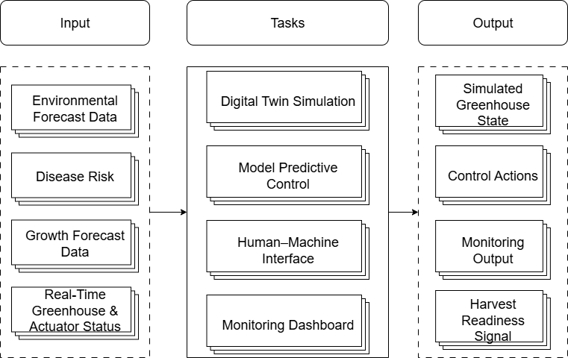
Fig. 5.4 Task-Level Architecture of Digital Twin Simulation and Intelligent Greenhouse Control Module
A. Digital Twin Simulation
The digital twin environment simulation task focuses on creating a virtual representation of the greenhouse system that reflects real-time environmental conditions and crop states. This virtual model simulates greenhouse dynamics, including environmental changes and crop development processes. The simulation environment allows the system to visualize crop growth stages and evaluate environmental variations within the greenhouse. In addition, the digital twin supports what-if scenario analysis, enabling the system to explore potential outcomes of different environmental conditions or control actions before implementation.
B. Model Predictive Control
The model predictive control task is responsible for optimizing greenhouse climate parameters using predictive control strategies. Greenhouse conditions such as temperature and humidity require continuous regulation to maintain optimal plant growth environments. This task evaluates predicted environmental states and determines appropriate control actions to regulate greenhouse climate variables. By considering multiple environmental factors simultaneously, the system generates actuator control decisions that improve climate stability and enhance energy-efficient greenhouse operation.
C. Human–Machine Interaction Interface
The human–machine interaction interface is designed to communicate system insights and control recommendations to greenhouse workers in an intuitive and accessible manner. Instead of presenting complex technical outputs, the interface uses simplified visual indicators and symbol-based notifications to convey system decisions. Color-coded alerts and graphical indicators help workers quickly understand greenhouse conditions and required actions. This approach enables effective communication between the intelligent system and human operators while supporting practical greenhouse management.
D. Real-Time Monitoring Dashboard
The real-time monitoring dashboard provides a visual interface for observing greenhouse conditions and system predictions. It displays live environmental data, crop health indicators, and disease alerts in an organized and interactive format. The dashboard also presents environmental trend graphs and system status updates, allowing users to monitor greenhouse performance continuously. By combining real-time monitoring with predictive insights, the dashboard supports informed decision-making and improves overall greenhouse management efficiency.
6. MODULE 1 — DATA PROCESSING AND AI-BASED CROP INTELLIGENCE
This section describes the implementation of the Data Processing and AI-Based Crop Intelligence module in the AgriTwin-GH system. It explains how agricultural datasets and plant images are processed using data preprocessing techniques and deep learning models to identify crop growth stages and detect plant diseases.
6.1 OVERVIEW OF THE MODULE
The Data Processing and AI-Based Crop Intelligence Module forms the foundation of the AgriTwin-GH system by transforming raw greenhouse data into actionable crop intelligence. It integrates environmental dataset preparation with image-based plant analysis to support accurate monitoring of crop conditions inside the greenhouse. Through unified data processing, crop growth stage classification, and plant disease detection, the module enables reliable interpretation of both environmental and visual crop information. By combining data preprocessing techniques with deep learning models, this module provides the essential insights required for subsequent predictive analytics and digital twin–based greenhouse management.
6.2 UNIFIED DATA PROCESSING PIPELINE
The Unified Data Processing Pipeline is used to transform heterogeneous environmental data into a standardized greenhouse dataset suitable for downstream AI analysis. Initially, raw environmental information is collected from external weather API data sources, which may contain incomplete records, inconsistent timestamps, and noise typical of real-world agricultural datasets. This data is first passed to the Data Ingestion component, where the system collects and integrates incoming environmental measurements into the internal processing framework. The next stage performs Data Validation and Cleaning, where corrupted entries, inconsistent values, and anomalous measurements are identified and corrected or removed. Following this, the Missing Value Handling stage ensures that incomplete records are properly treated using appropriate imputation strategies so that the dataset remains consistent and usable for machine learning applications. The processed data then undergoes Temporal Synchronization, where all environmental parameters such as temperature, humidity, carbon dioxide concentration, and light intensity are aligned along a consistent time axis to maintain accurate temporal relationships between variables. Finally, the Feature Engineering stage derives meaningful environmental indicators and structured variables that better represent greenhouse conditions. The result of this pipeline is a Standardized Greenhouse Dataset, which serves as a reliable and structured input for subsequent AI-based crop intelligence models within the AgriTwin-GH platform.
Fig. 6.1 illustrates the Data Processing Pipeline Architecture, showing how raw environmental data from weather API sources is ingested, validated, cleaned, temporally synchronized, and transformed through feature engineering to generate a standardized greenhouse dataset for AI-based crop analysis.

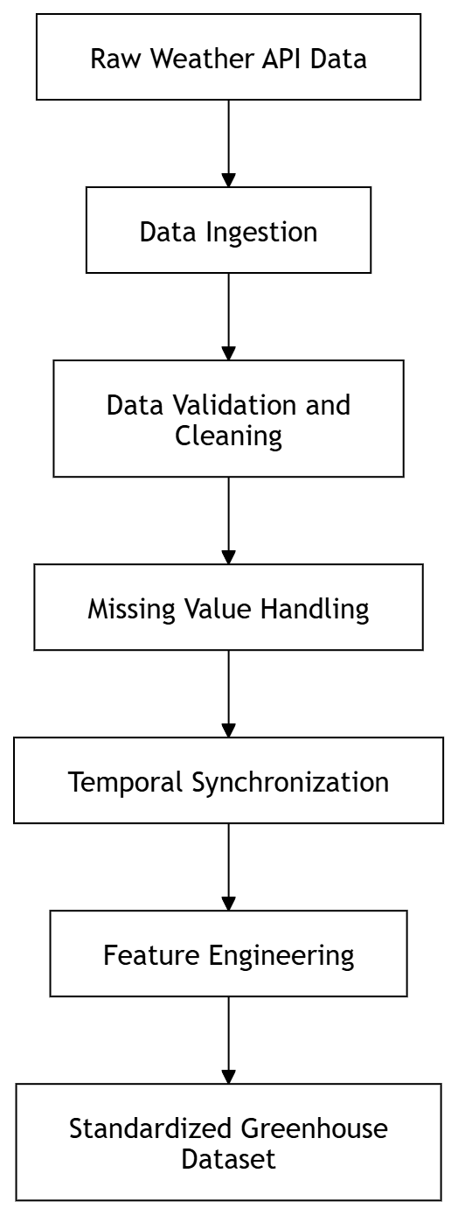
Fig. 6.1 Data Processing Pipeline Architecture
6.3 AI-BASED CROP INTELLIGENCE WORKFLOW
The AI-based crop intelligence workflow illustrates how plant image data is processed through a series of computer vision and deep learning operations to perform crop growth stage classification and plant disease detection in the AgriTwin-GH system. Initially, plant image data collected from greenhouse crops is passed through image preprocessing and augmentation stages to improve input consistency and increase dataset diversity. The processed images are then analyzed using a convolutional neural network–based feature extraction process, where important visual patterns related to plant structure and leaf conditions are extracted. These features are subsequently processed by the EfficientNet deep learning model, which serves as the primary classification architecture. The model simultaneously performs two analytical tasks: identifying the crop growth stage of tomato plants and detecting potential plant diseases affecting greenhouse crops. The outputs generated from these tasks are then combined to produce meaningful crop intelligence results such as growth stage labels and plant disease labels that support greenhouse crop monitoring and management.
Fig. 6.2 illustrates the Growth Stage Classification and Disease Detection workflow, showing how plant image data is processed through preprocessing, augmentation, CNN-based feature extraction, and the EfficientNet model to generate crop growth stage predictions and plant disease detection results.
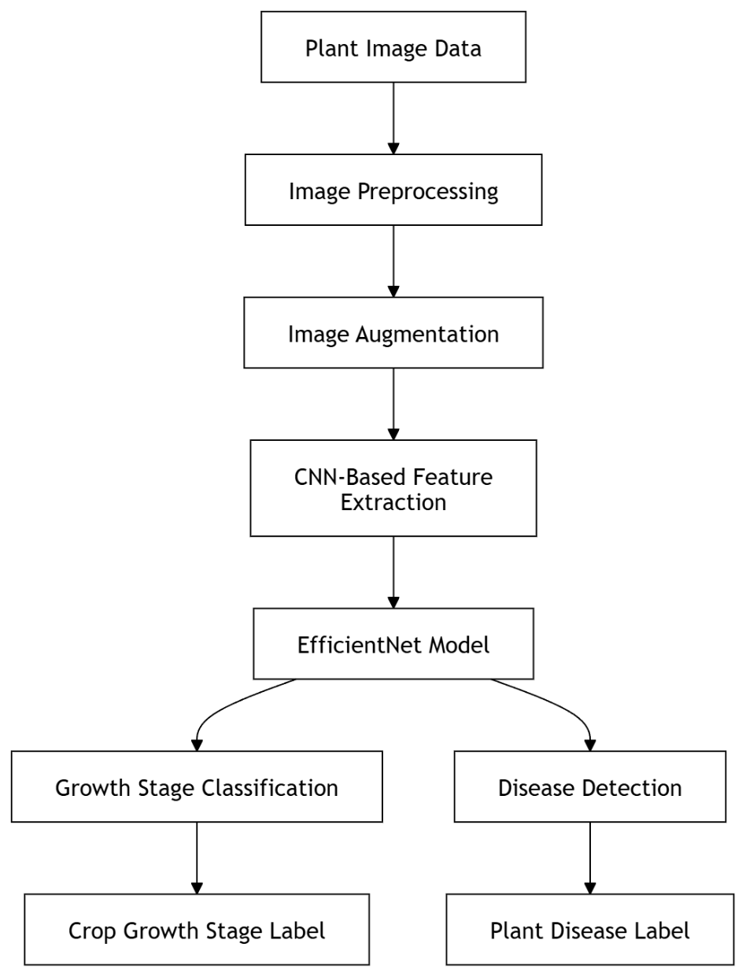
Fig. 6.2 Growth Stage Classification and Disease Detection Workflow
6.4 COMPONENT-LEVEL DESIGN OF THE MODULE
The component-level design of Module 1 defines the internal architectural structure that enables the AgriTwin-GH system to transform heterogeneous greenhouse data and plant image inputs into actionable crop intelligence. The module is organized into functional layers: Inputs, Core Processing, AI Analysis, Output Management, and Outputs. In the input layer, environmental data obtained from weather API sources and plant image datasets collected from greenhouse crops are introduced into the system. These inputs are passed to the Data Ingestion Component, which integrates the heterogeneous data sources and converts them into a unified internal representation suitable for further processing. The Data Preprocessing Component then performs several data preparation operations including data validation, cleansing, and normalization to ensure the reliability and consistency of the collected information. Following preprocessing, the Feature Engineering Component extracts meaningful environmental indicators and structured features that improve the effectiveness of downstream machine learning models. The processed environmental features and plant image data are subsequently forwarded to the AI Analysis layer, where deep learning models perform crop growth stage classification and plant disease detection using visual patterns extracted from plant images. The classification outputs are then passed to the Output Management layer, where confidence scores and prediction results are organized by the Result Manager to generate structured outputs such as standardized greenhouse datasets, crop growth stage predictions, and disease detection results. This component-oriented design ensures modular processing, clear separation of responsibilities between system layers, and efficient integration of environmental data processing with computer vision-based crop intelligence within the AgriTwin-GH platform.
Fig. 6.3 illustrates the component-level architecture of the Data Processing and AI-Based Crop Intelligence Module, showing how environmental datasets and plant image inputs are processed through data ingestion, preprocessing, feature engineering, and AI analysis components to produce growth stage predictions and plant disease detection results.
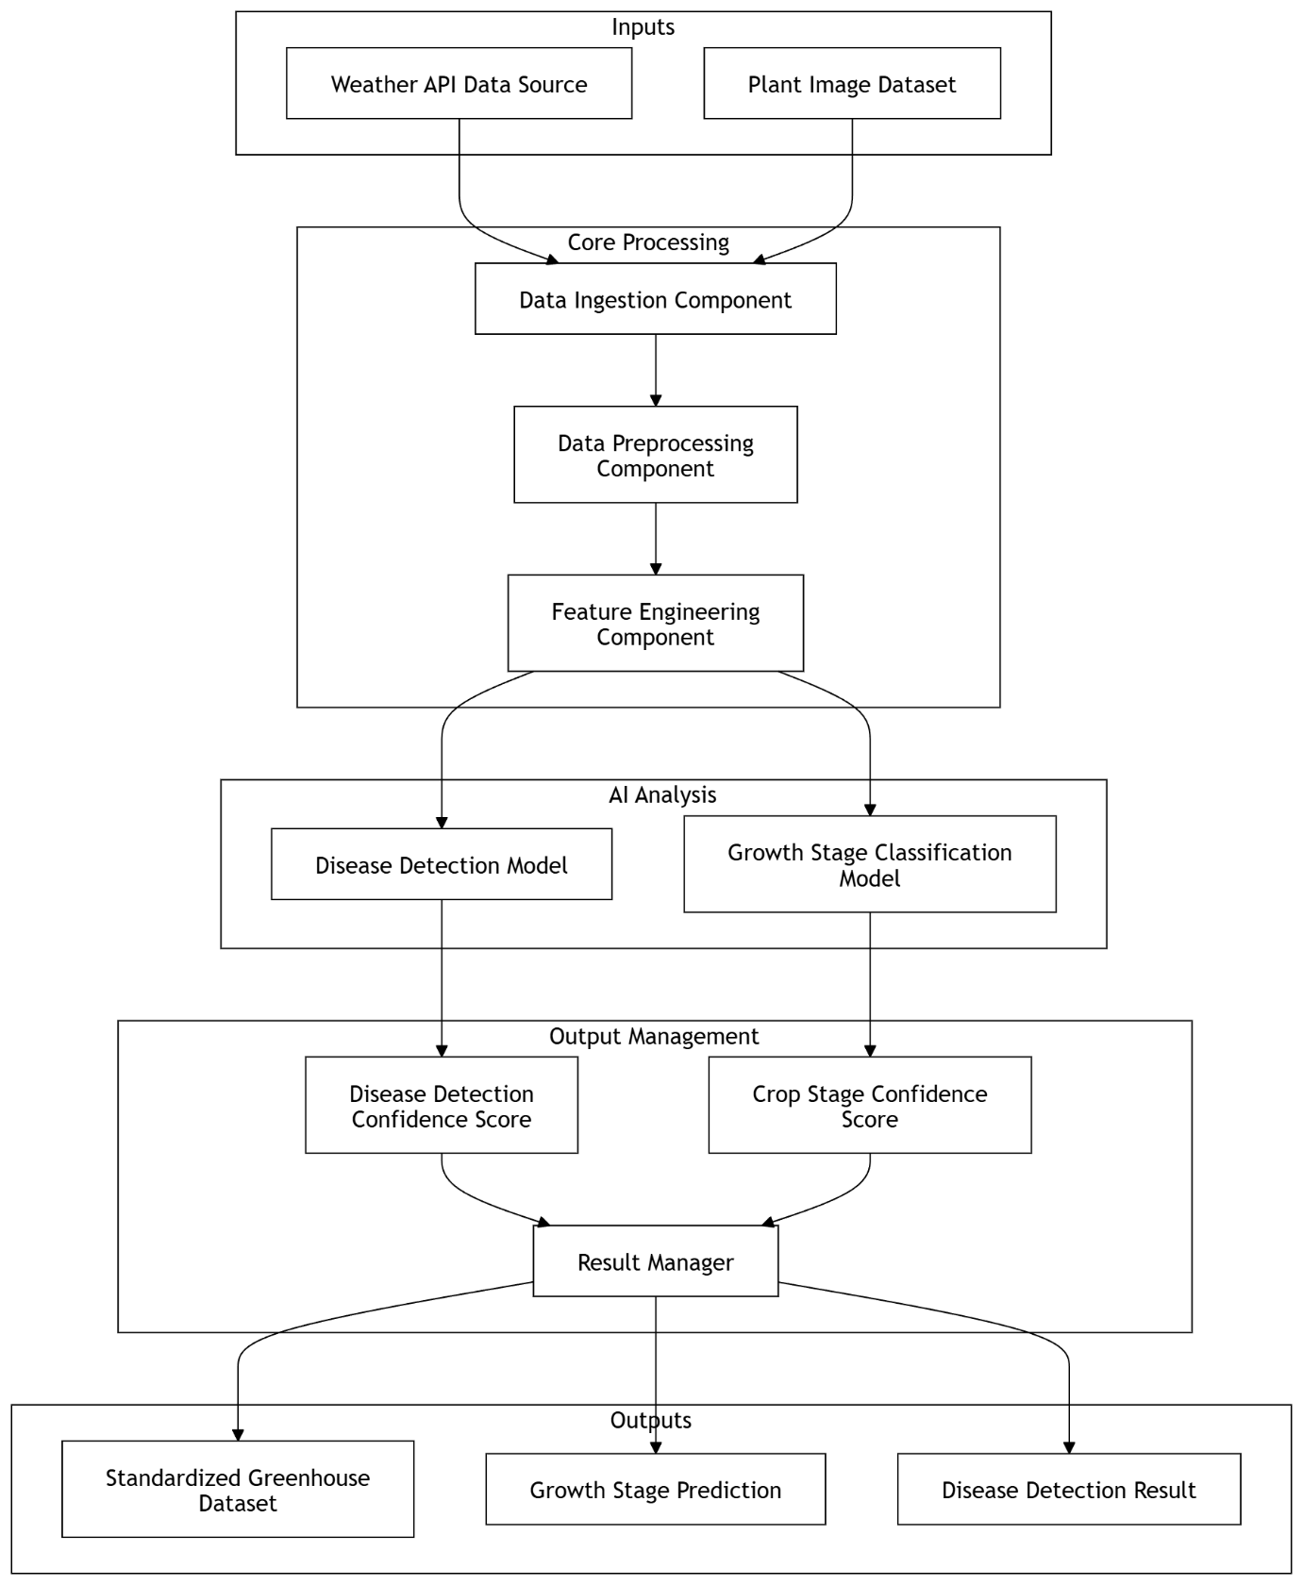
Fig. 6.3 Architectural Component Design of Module 1
6.5 MODULE DEMONSTRATION
A. Data Processing Feature Demonstration
The data processing demonstration illustrates how raw outdoor weather data is transformed into a structured indoor greenhouse dataset used by the AgriTwin-GH system. The input data contains environmental variables such as temperature, humidity, wind speed, solar radiation, and timestamps, which are collected from weather datasets for the Dindigul region. These measurements are first standardized and expanded into hourly records to simulate continuous greenhouse monitoring conditions.
Using these environmental inputs, several greenhouse features are derived to represent realistic indoor cultivation conditions. Outdoor temperature and solar radiation are used to estimate indoor temperature, while outdoor humidity and temperature variation are used to compute indoor humidity levels. Similarly, outdoor wind speed is converted into indoor air velocity, representing the reduced airflow inside the greenhouse structure. Based on the calculated indoor environmental variables, additional agronomic indicators are extracted. Indoor temperature and humidity are used to compute dew point temperature, and together they are also used to calculate the Vapor Pressure Deficit (VPD), which indicates plant transpiration stress levels. Furthermore, high indoor humidity sustained for multiple hours is used to derive a leaf wetness proxy indicator, which helps identify potential disease-favorable conditions inside the greenhouse.
The final processed dataset contains key greenhouse parameters including indoor temperature, indoor humidity, indoor air velocity, CO₂ concentration, solar radiation, vapor pressure deficit (VPD), dew point temperature, and leaf wetness indicators. This standardized dataset serves as the primary environmental input for subsequent AI-based modules in the AgriTwin-GH system.
Fig. 6.4 illustrates a sample of the raw environmental dataset retrieved from the weather API, showing the outdoor climatic parameters that serve as the initial input for the AgriTwin-GH data processing pipeline.
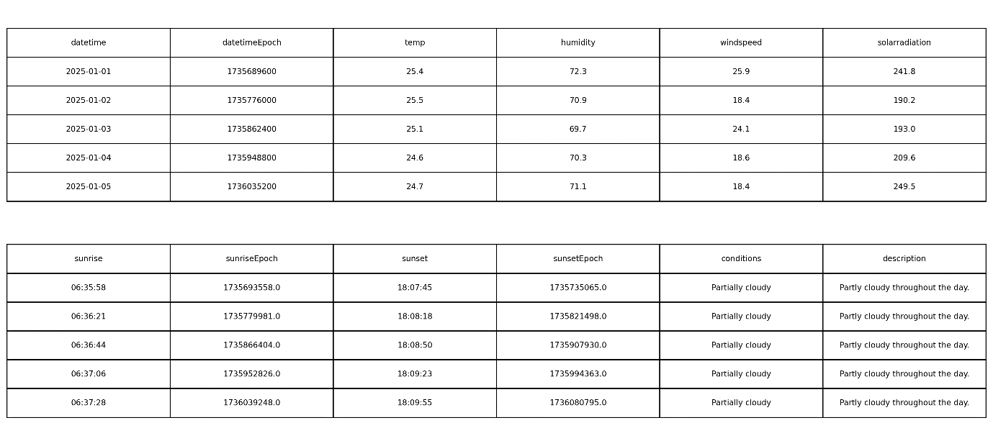
Fig. 6.4 Extract of the Dindigul Weather Dataset

Environmental Feature Calculation Formulas
Using the environmental parameters obtained from the weather API, several greenhouse environmental variables and agronomic indicators are derived through the following mathematical formulations.
a. Indoor Temperature Calculation
Indoor temperature is estimated based on outdoor temperature and solar radiation intensity.
Daytime Condition:
$$ΔT=0.02×SolarRadiation \\ IndoorTemp=OutdoorTemp+ΔT$$
Nighttime Condition:
$$IndoorTemp=OutdoorTemp+1.5$$
b. Indoor Humidity Calculation
Indoor humidity is estimated based on the effect of temperature variation and evapotranspiration.
Daytime Condition:
$$IndoorHumidity=OutdoorHumidity-(0.5×ΔT)+0.4$$
Nighttime Condition:
$$IndoorHumidity=OutdoorHumidity+5$$
c. Indoor Air Velocity
Indoor air velocity is derived from outdoor wind speed.
IndoorAirVelocity = OutdoorWindSpeed×0.1
d. Indoor CO₂ Concentration
CO₂ levels vary between daytime and nighttime conditions due to plant physiological processes.
Daytime:
$$IndoorCO2​=400-(0.05×SolarRadiation)$$
Nighttime:
$$IndoorCO2​=440$$
e. Dew Point Temperature
Dew point temperature is estimated using a simplified approximation.
$$DewPoint=IndoorTemp-5(100-IndoorHumidity)​$$
f. Vapor Pressure Deficit (VPD)
VPD is calculated to measure plant transpiration and moisture stress.
Saturation Vapor Pressure:
$$SVP = 0.6108 * e^{\left\{\frac{17.27T}{T + 237.3}\right\}}$$
Actual Vapor Pressure:
$$AVP = SVP * \left(RH/100\right)$$
Vapor Pressure Deficit:
$$VPD=SVP-AVP$$
Where,
T = Indoor Temperature (°C)
RH = Indoor Relative Humidity (%)
g. Leaf Wetness Proxy Indicator
Leaf wetness is detected based on sustained high humidity levels.
$$LeafWetness=1 if IndoorHumidity>85\% for ≥ 3 consecutive hours$$
Otherwise:
$$LeafWetness=0$$
B. Disease Detection Demonstration
For the disease detection task, a tomato leaf image dataset is organized into six classes representing common tomato plant diseases and healthy leaf conditions. The classes include Tomato Early Blight, Tomato Late Blight, Tomato Leaf Mold, Tomato Powdery Mildew, Tomato Spider Mites, and Healthy Leaf. These images capture the visual symptoms of each disease, enabling the model to learn disease-specific patterns present on tomato leaves.
The dataset is divided into training, validation, and test sets to ensure proper model learning and evaluation. The training set is used for model learning, the validation set monitors performance during training, and the test set evaluates the final model on unseen images, preventing overfitting and improving reliability.
The disease detection model uses EfficientNetB0 with transfer learning for efficient feature extraction and image classification. Training is performed in two stages: first training a custom classification head, followed by fine-tuning the upper layers of the network. The model is trained using Categorical Cross-Entropy loss with label smoothing to improve classification stability. During prediction, the model analyzes a leaf image and produces outputs including the predicted disease label, confidence score, and top predicted classes, which help identify plant health conditions within the greenhouse monitoring system.
Fig. 6.5 illustrates representative tomato leaf images used in the dataset for training the plant disease detection model.
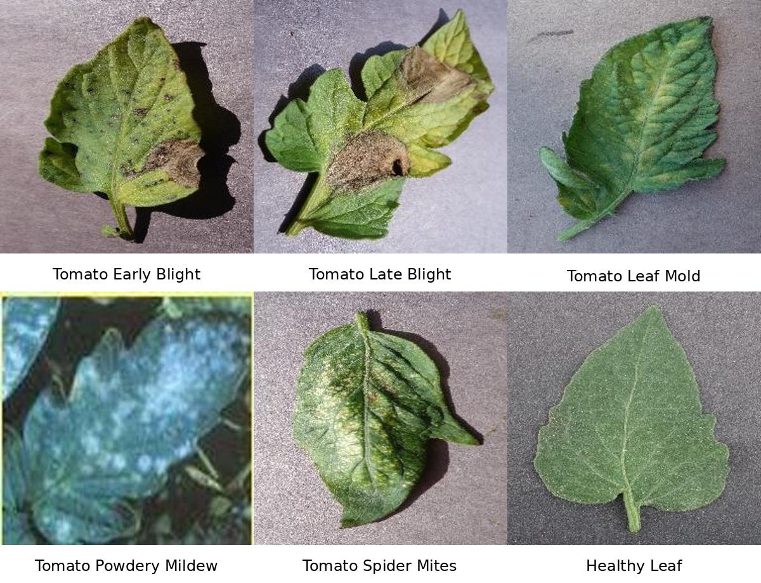
Fig. 6.5 Tomato Leaf Disease Classification Dataset Samples
Fig. 6.6 illustrates the training log of the Phase-1 warm-up stage, where the EfficientNetB0 backbone remains frozen and only the custom classification head is trained. The figure shows the progressive improvement of training and validation accuracy during initial epochs, demonstrating how the model begins learning disease-specific features from tomato leaf images.
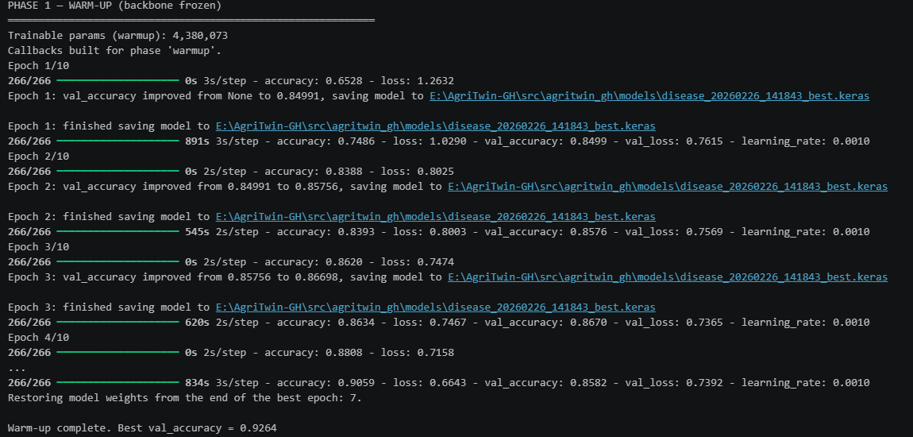
Fig. 6.6 Phase-1 Warm-Up Training Results for Disease Classification Model
Fig. 6.7 illustrates the Phase-2 fine-tuning stage, where selected backbone layers of the EfficientNetB0 model are unfrozen and trained to improve feature representation. The figure shows the improvement in validation accuracy during fine-tuning, resulting in the final optimized model used for tomato disease detection in the AgriTwin-GH system.
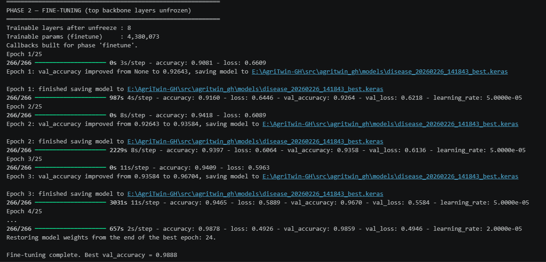
Fig. 6.7 Phase-2 Fine-Tuning Results for Disease Classification Model
C. Growth Stage Classification Demonstration
For the growth stage classification task, a tomato plant image dataset is organized into six growth stage categories representing key phases of plant development: Seedling, Early Vegetative, Flowering Initiation, Flowering, Unripe Fruit, and Ripe Fruit. Each category contains images that reflect the visual characteristics observed during the corresponding stage of the tomato growth cycle, enabling the model to learn stage-specific plant morphology.
To ensure reliable training and evaluation, the dataset is divided into three subsets: 75% for training, 15% for validation, and 10% for testing. A stratified splitting strategy is applied so that each growth stage category is proportionally represented across all subsets, helping maintain balanced learning and accurate model evaluation.
To improve the model’s generalization ability, controlled data augmentation techniques are applied to the training images. These include horizontal flipping, small rotations, zoom operations, brightness adjustments, and mild color variations. The augmentation intensity is kept moderate to preserve important plant color and structural features that are essential for distinguishing different tomato growth stages.
Fig. 6.8 illustrates sample tomato plant images representing the six growth stage categories used in the dataset: Seedling, Early Vegetative, Flowering Initiation, Flowering, Unripe Fruit, and Ripe Fruit.
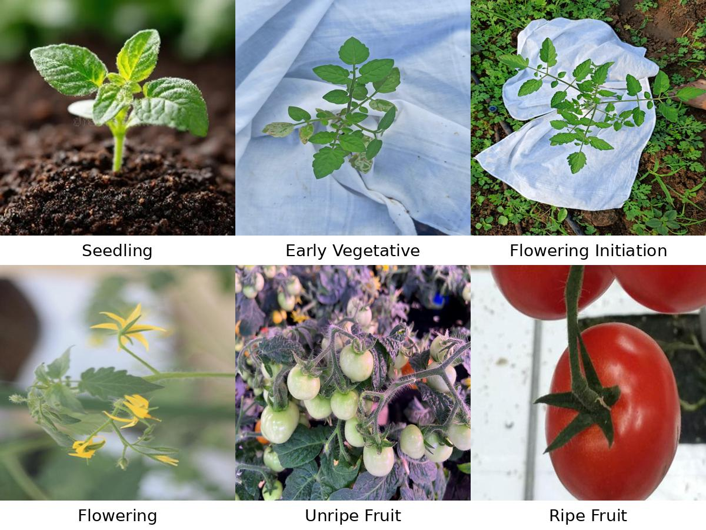
Fig. 6.8 Tomato Crop Growth Stages Dataset Samples
Fig. 6.9 illustrates the training log of the Phase-1 warm-up stage for the tomato growth stage classification model, where the EfficientNet backbone layers remain frozen and only the newly added classification layers are trained. The figure shows the initial improvement in training and validation accuracy as the model begins learning visual patterns corresponding to different tomato growth stages.
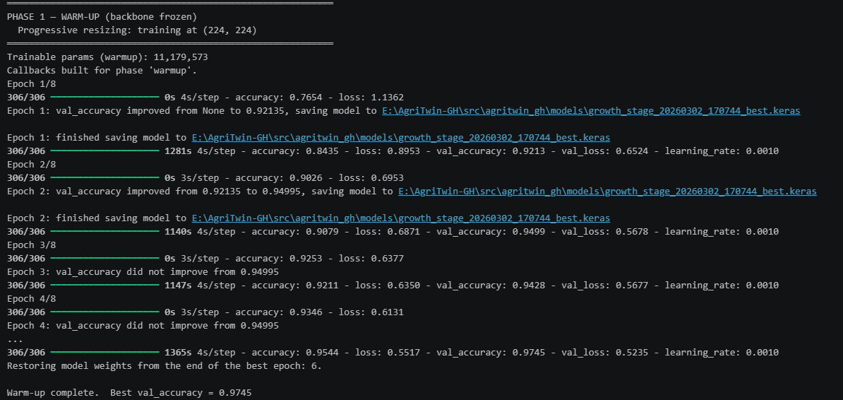
Fig. 6.9 Phase-1 Warm-Up Training Results for Growth Stage Classification Model
Fig. 6.10 illustrates the Phase-2 fine-tuning stage of the growth stage classification model, where selected backbone layers are unfrozen and trained along with the classification head. The training results demonstrate improved validation accuracy after fine-tuning, indicating that the model has effectively adapted to recognize tomato plant growth stages more accurately.
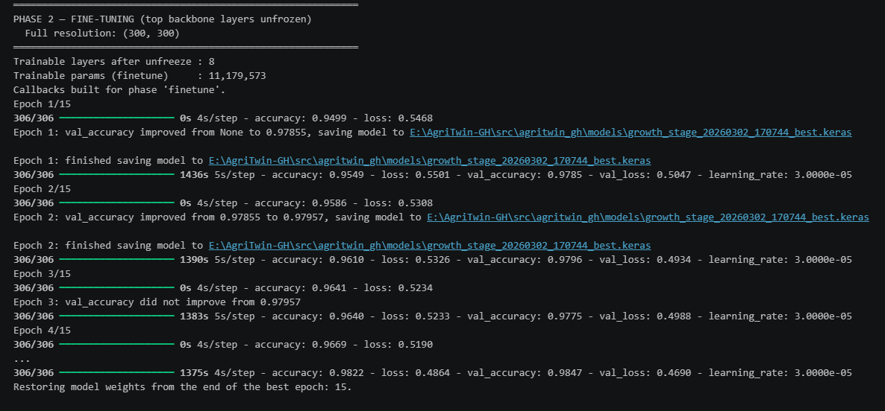
Fig. 6.10 Phase-2 Fine-Tuning Results for Growth Stage Classification Model
6.6 IMPLEMENTATION RESULTS AND PERFORMANCE ANALYSIS
A. Data Processing Feature
Fig. 6.11 illustrates the first few records of the processed greenhouse environmental dataset after data cleaning, temporal synchronization, and feature engineering applied in the AgriTwin-GH data processing pipeline.
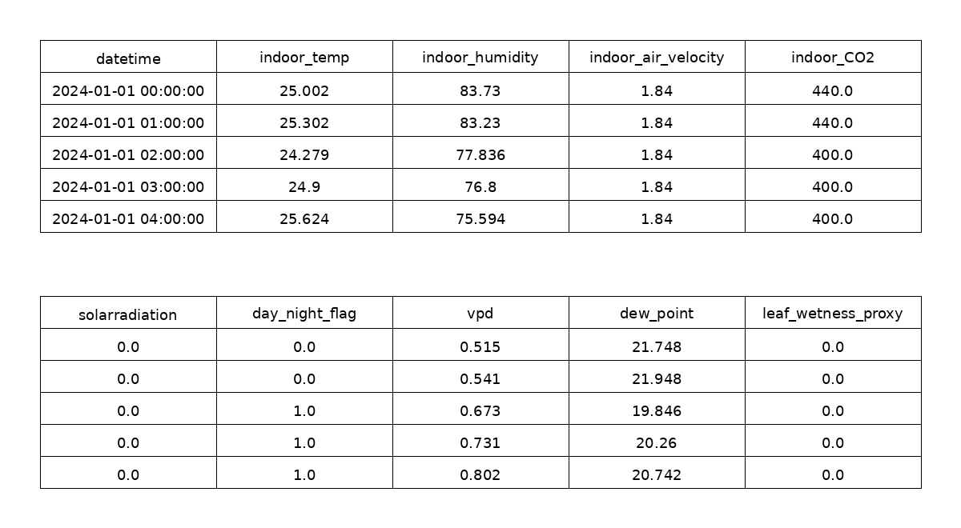
Fig. 6.11 Processed Greenhouse Environmental Dataset Sample
B. Disease Detection Performance
Fig. 6.12 illustrates the confusion matrix showing the classification performance of the tomato disease detection model across the six disease categories.
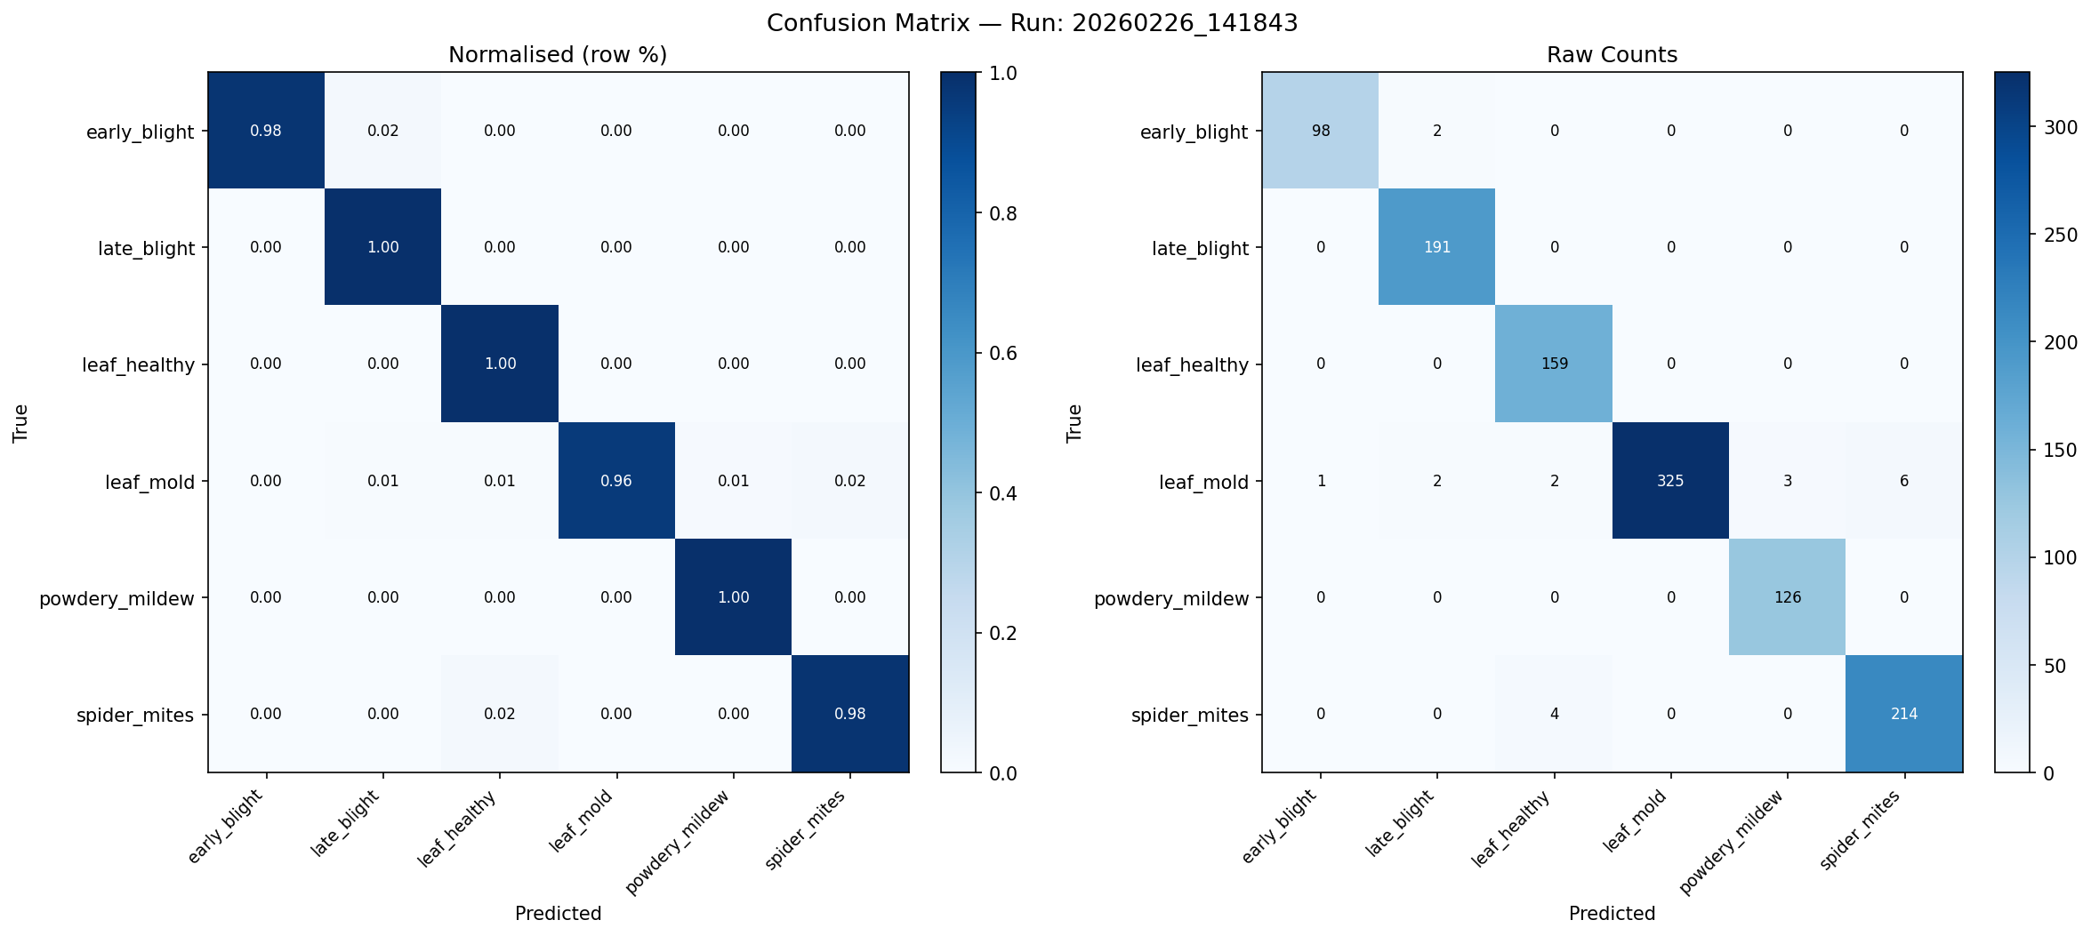
Fig. 6.12 Confusion Matrix of Tomato Disease Detection Model
Fig. 6.13 illustrates the variation of training and validation accuracy across epochs during the training process of the tomato disease detection model.
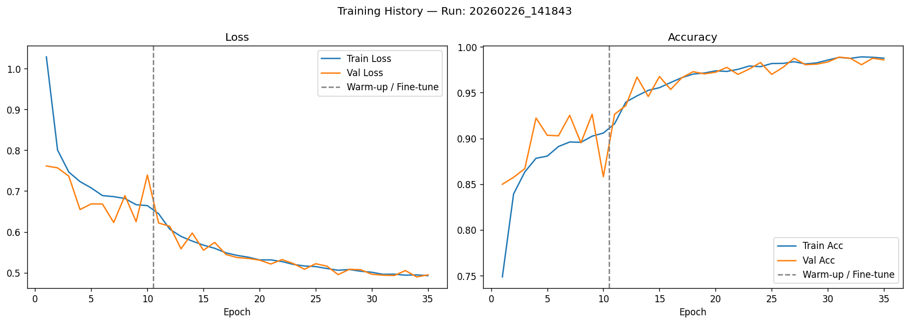
Fig. 6.13 Training Accuracy of the Disease Detection Model
Fig. 6.14 illustrates the change in training and validation loss values during model training, indicating the convergence behavior of the tomato disease detection model.

Fig. 6.14 Training Loss of the Disease Detection Model
C. Growth Stage Classification Performance
Fig. 6.15 illustrates the confusion matrix showing the classification accuracy of the tomato growth stage classification model across the different plant development stages.
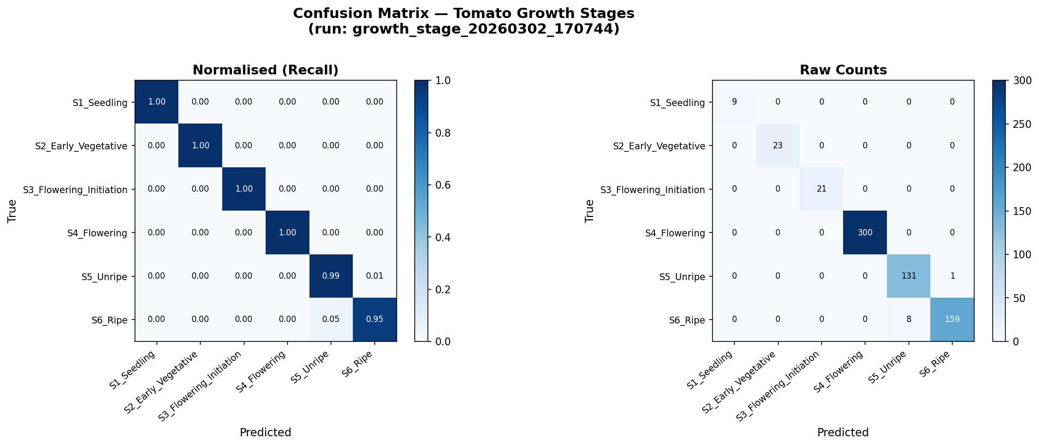
Fig. 6.15 Confusion Matrix of Tomato Growth Stage Classification Model
Fig. 6.16 illustrates the progression of training and validation accuracy across epochs during the training of the tomato growth stage classification model.
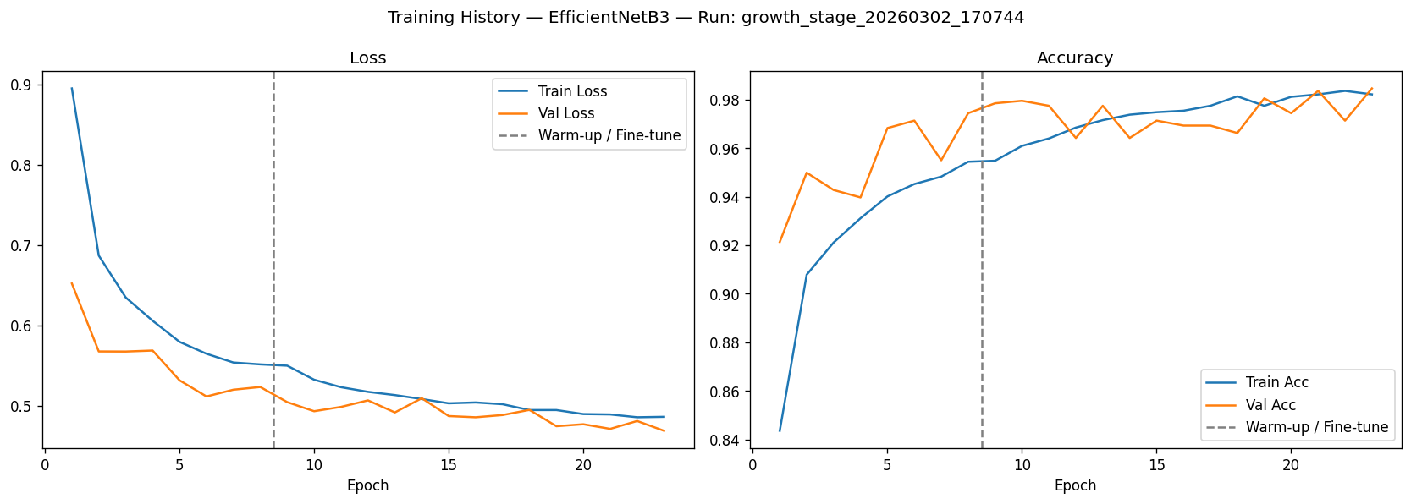
Fig. 6.16 Training Accuracy of the Growth Stage Classification Model
Fig. 6.17 illustrates the variation of training and validation loss values across epochs, reflecting the learning stability of the tomato growth stage classification model.

Fig. 6.17 Training Loss of the Growth Stage Classification Model
7. CONCLUSION
This report presented the development of the proposed AgriTwin-GH system, focusing on the design of an intelligent framework for greenhouse monitoring and crop analysis. The system architecture was structured through modular decomposition, enabling a clear separation of data processing, predictive analysis, and digital twin–based greenhouse control functionalities.
Each module and its corresponding tasks were described explicitly and in detail to illustrate the internal workflow and functional responsibilities within the system. The report also documented the techniques, algorithms, and methodologies employed in the implementation, along with demonstrations, system outputs, screenshots, and visual representations that validate the development of Data Processing and AI-Based Crop Intelligence Module. Overall, the presented work establishes a structured foundation for intelligent greenhouse monitoring and supports future development of AI-driven greenhouse management systems.
8. DATASETS USED
S. No | Dataset Name | Source | Description | Link
1 | PlantVillage | Kaggle | Image dataset containing healthy and diseased plant leaves used for plant disease classification. | https://www.kaggle.com/datasets/arjuntejaswi/plant-village
2 | Ripe and Unripe Tomatoes Dataset | Kaggle | Contains images used to classify tomato ripeness stages in greenhouse environments. | https://www.kaggle.com/datasets/adilshamim8/greenhouse-plant-growth-metrics
3 | Tomato Disease Dataset | Mendeley Data | Dataset containing tomato leaf images with various disease classes for detection models. | https://data.mendeley.com/datasets/c2x8rynybg/1
4 | Tomato-flower-3-class | Kaggle | Image dataset containing three classes of tomato flower stages for classification tasks. | https://www.kaggle.com/datasets/jawadulkarim117/tomato-flower-3-class
5 | TomatoPlantfactoryDataset | Mendeley Data | Dataset collected from controlled plant factory environments containing tomato growth images and data. | https://data.mendeley.com/datasets/8h3s6jkyff/1
6 | Tomato Plant Stages Dataset | Kaggle | Dataset containing images of different tomato plant growth stages for plant lifecycle analysis. | https://www.kaggle.com/datasets/arjunsudheer326/tomato-plant-stages-dataset
9. REFERENCES
[1] E. Elbasi, N. Mostafa, C. Zaki, Z. AlArnaout, A. E. Topcu, and L. Saker, “Optimizing agricultural data analysis techniques through AI-powered decision-making processes,” Applied Sciences, vol. 14, no. 8018, 2024.
[2] M. Ghiasi, Z. Wang, M. Mehrandezh, and A. Mohammadi, “Optimal strategy for energy-efficient management of greenhouse climate control,” IEEE Open Access Journal of Power and Energy, vol. 12, pp. 1–14, Dec. 2025.
[3] D. A. Howard, Z. Ma, C. Veje, A. Clausen, J. M. Aaslyng, and B. N. Jørgensen, “Greenhouse industry 4.0 – digital twin technology for commercial greenhouses,” Energy Informatics, vol. 4, no. 1, pp. 1–20, May 2021.
[4] Y. Huo, Y. Liu, P. He, L. Hu, W. Gao, and L. Gu, “Identifying tomato growth stages in protected agriculture with StyleGAN3–synthetic images and Vision Transformer,” Agriculture, vol. 15, no. 120, 2025.
[5] D. S. Joseph, P. M. Pawar, and K. Chakradeo, “Real-time plant disease dataset development and detection of plant disease using deep learning,” IEEE Access, vol. 11, pp. 1–15, 2023.
[6] A. Kaur and R. Kaur, “AI-enabled energy management for sustainable smart greenhouses: An integrated review,” Journal of Cleaner Production, vol. 382, pp. 1–15, 2024.
[7] D. K. Lee, B. K. Kang, Y. J. Kim, T. G. An, and Y. T. Chae, “A digital twin-based framework for precision tomato cultivation: Integrating XGBoost-based prediction with model predictive control,” SSRN Electronic Journal, 2024.
[8] S. R. Luna, M. P. García, and J. R. Torres, “Digital twin technology in greenhouse-based precision agriculture,” Computers and Electronics in Agriculture, vol. 209, pp. 107–119, 2023.
[9] B. V. Nikitha, N. K. S. Keerthan, P. Praneeth, and T. Amrita, “Leaf disease detection and classification,” Procedia Computer Science, vol. 218, pp. 291–300, Jan. 2023.
[10] A. Oad, S. S. Abbas, A. Zafar, et al., “Plant leaf disease detection using ensemble learning and explainable AI,” IEEE Access, vol. 12, pp. 156038–156052, 2024.
[11] A. Soussi, E. Zero, C. D. C. Herrera, et al., “Integrating digital twins and model predictive control for sustainable greenhouse management in smart agriculture,” IEEE Transactions on AgriFood Electronics, vol. 1, no. 1, pp. 1–17, 2025.
[12] A. F. Subahi and K. E. Bouazza, “An intelligent IoT-based system design for controlling and monitoring greenhouse temperature,” IEEE Access, vol. 10, pp. 1–12, 2022.
[13] R. A. Tathed, “Designing AI-driven platforms to transform agricultural ecosystems,” International Journal for Research Publication and Seminar, vol. 16, no. 2, pp. 249–268, Apr.–Jun. 2025.
[14] M. Umar, S. Altaf, S. Ahmad, H. Mahmoud, A. S. N. Mohamed, and R. Ayub, “Precision agriculture through deep learning: Tomato plant multiple diseases recognition with CNN and improved YOLOv7,” IEEE Access, vol. 12, pp. 49167–49180, Apr. 2024.

